|  |
| --- |
|  |
| *Model-Based Construction And Optimisation Of Versatile Chassis Yeast Strains For Production Of Valuable Lipid And Aromatic Compounds* |
|  |
| **D2.3** |
| A strategy setting out the proposed optimal engineering approach to construct level 1 chassis strains |
| WP2 Improvement and application of genome-scale metabolic models in yeasts |
| Status: Draft |
| 11 May 2018 |
|  |
| **Grant Agreement No.: 720824** |

|  |  |  |  |  |
| --- | --- | --- | --- | --- |
|  | C:\Users\ltaylor\AppData\Local\Microsoft\Windows\INetCache\Content.Outlook\V2U287U6\CHALMERS.JPG |  | http://www.pegnet.ifw-kiel.de/global-images/logo_universitaet_frankfurt.gif/ | French National Institute for Agricultural Research |
| Image result for biopetrolia | http://www.evolva.com/wp-content/uploads/2015/12/evolvalogo4.jpg |  | Related image |  |

**Document Information**

|  |  |
| --- | --- |
| **Title** | Transcriptome, proteome and metabolome data sets prepared in a database-ready format for the three yeast species |
| **Distribution** | Confidential |
| **Deliverable Leader** | |  |  | | --- | --- | | Verena Siewers |  |   Chalmers |
| **Contributing Authors** | |  |  | | --- | --- | | Iván Domenzain |  |   Chalmers  Choose an organisation. |

**Revision History**

|  |  |  |  |  |  |
| --- | --- | --- | --- | --- | --- |
| **Rev.** | **Date** | **Description** | **Prepared by (Name & Org.)** | **Approved By (Work-Package Leader)** | **Status (Draft/Final)** |
| 01 | 11/05/18 | Initial Draft | Verena Siewers, Chalmers |  | Draft |
| 02 |  |  |  |  |  |
| 03 |  |  |  |  |  |

**Legal Disclaimer**

The views expressed, and responsibility for the content of this publication, lie solely with the authors. The European Commission is not liable for any use that may be made of the information contained herein. This work may rely on data from sources external to the CHASSY project Consortium. Members of the Consortium do not accept liability for loss or damage suffered by any third party as a result of errors or inaccuracies in such data. The information in this document is provided “as is” and no guarantee or warranty is given that the information is fit for any particular purpose. The user thereof uses the information at its sole risk and neither the European Commission nor any member of the CHASSY Consortium is liable for any use that may be made of the information.

Contents

Executive Summary 4

About CHASSY 4

1. Planned strain modifications 5

2. Incorporation of proteomics data 6

3. *In-silico* assessment of the natural capabilities for precursors production 7

4. Systematic search of metabolic engineering targets 11

5. References 20

Annex I: *In-Silico* strains modifications 21

# Executive Summary

# About CHASSY

CHASSY will unlock the full potential of the yeasts *Saccharomyces cerevisiae*, *Yarrowia lipolytica* and *Kluyveromyces marxianus* as cell factories for production of high value compounds which have applications in the cosmetic, nutraceutical and white biotechnology sectors.

Current cell factory strains for these classes of product are restricted to proof-of-principle levels because of limited precursor supply, poor product tolerance, and lack of versatility. CHASSY addresses these challenges by redesigning metabolic circuits and expanding the host range to include the oleaginous yeast, *Y. lipolytica* and the thermotolerant yeast, *K. marxianus*.

The systems biology approach will integrate model-based design, construction and analysis of yeast strains, resulting in reconfigured metabolic networks optimised for the production of lipid and aromatic molecules. Construction of the chassis strains, using new and existing synthetic biology tools, will be directed by knowledge derived from a thorough systems biology comparison of the three yeast species, conducted using integrative data analysis and genome scale metabolic models.

These new cell factory strains will be evaluated under industrial conditions to produce data that will further improve the chassis platforms. The major outcomes of this project will be (1) a new set of chassis yeast strains that are widely applicable for development of industrial cell factories; (2) the knowledge and technology to readily build and evaluate new chassis tailored to specific applications; (3) prototype cell factory strains producing three high value metabolites for commercial exploitation; (4) a dissemination and exploitation strategy to ensure that European SMEs benefit from the knowledge base, platform chassis and resources generated in CHASSY.

# Planned strain modifications

In order to accomplish the goal of constructing chassis strains, suitable for the production of a wide variety of added value compounds, the net flux towards metabolic precursors needs to be enhanced. Currently, this project focuses on the production of three specific high value products: the oleochemicals, Docosanol and Octanoic acid; and the aromatic molecule, Amorfrutin 1. The precursors needed for these targets molecules are shown in ***figure 1***. Additionally, an increased pool of the cofactor NADPH is desired for both fatty acids and aromatic amino acids production.

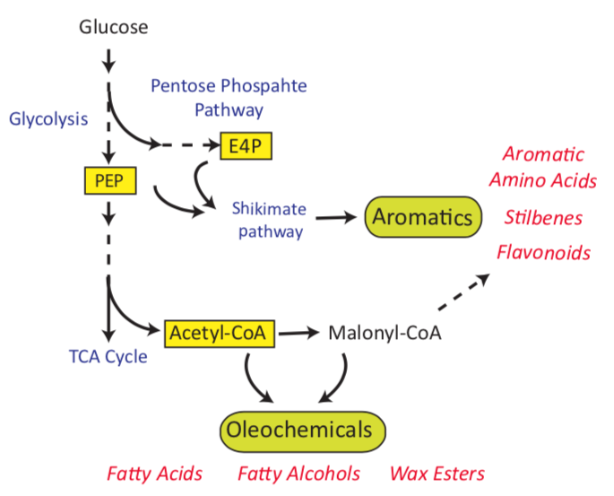

***Figure 1:*** *Precursor metabolites for a wide variety of chemicals. PEP is used for phosphoenolpyruvate and E4P for erithrose-4-phosphate.*

The CHASSY consortium has suggested prior metabolic engineering strategies on the three studied yeasts for enhancing the production of these metabolites and cofactors, which are listed on ***table 1***. These strategies have been incorporated into the enzyme-constrained genome scale metabolic models (EC-GEMs) constructed for this project for a quantitative exploration of their production capabilities and also for a systematic search of modifications that can increase the flux towards precursors even further. The specific characteristics of each mutant strain and the description of the *in-silico* construction process have been detailed on ***Annex I***.

Table 1: Proposed mutant strains for enhanced precursors production.

|  |  |  |  |
| --- | --- | --- | --- |
| Organism | Identifier | Production target | Comments |
| S. cerevisiae | Sce_AAA | PEP, E4P, Malonyl-CoA, NADPH | Details on table AI.1 |
| Sce_FAA | Acetyl-CoA, Malonyl-CoA, NADPH | Details on table AI.2 |
| *Y. lipolytica* | Yli_AAA | PEP, E4P, Malonyl-CoA, NADPH | Details on table AI.3 |
| Yli_FAA | Acetyl-CoA, Malonyl-CoA, NADPH | Details on table AI.4 |
| *K. marxianus* | Kma_AAA | PEP, E4P, Malonyl-CoA, NADPH | Details on table AI.5 |
| Kma_WT | Acetyl-CoA, Malonyl-CoA, NADPH | No strategy was proposed for these precursor on K. marxianus. So the wild type model was taken as a basis for the proposal of further strategies. |

# Incorporation of proteomics data

As part of this work package, extensive omics datasets have been collected for the three organisms growing on different conditions. The EC-GEMs were constructed in a general way for allowing the simulation of any condition of interest. Condition specific models can be obtained by the incorporation of individual protein levels as capacity constraints due to their linear relationship with the maximum attainable flux for a biochemical reaction (see deliverable 2.2 for details). Yet, there is no available method for identifying and measure all the proteins present in a biological sample and, as it is showed in ***figure 2***, not all the proteins that are taken into account by the models were able to be measured in the experimental part of this work package.

The GECKO modelling framework1 is as flexible that it allows to set bounds for unmeasured proteins too, by assuming a total protein pool from which every protein is taken, for this reason the total protein content for all conditions was also measured. In this study this single value has been used with a double purpose. First, it allows to approximate absolute protein abundances from relative proteomics data (spectral counts) according to

$\left[e_{i}\right]= f_{i}*\left(\frac{f*P_{tot}}{〈M_{W}〉}\right) [1]$

Where $e_{i}$ represents the concentration of the *i-th* protein in $\frac{mmol}{gDw}$; $f_{i}$, is the fraction of spectral counts for the *i-th* protein out of the total sum of spectral counts in a given sample; $〈M_{W}〉$, is the mean molecular weight for all the proteins in a given organism; finally, $f$ is and adjustable parameter that represents the mass fraction of modelled proteins out of the total proteome mass. These abundances are set as upper limits for the measured enzymes. Second, for all the unmeasured proteins a total remaining protein pool is assumed, in this way the model cannot allocate more protein mass for catalysing reactions than the one that was measured in total.

$e_{pool}≤ \left(P_{tot}-\sum_{i}^{P}{M_{Wi}e_{i}}\right) [2]$

Relative proteomics measurements and total protein contents for standard conditions have been incorporated to the three EC-GEMs and the resulting models are stored at the GitHub repositories indicated in the deliverable 2.2 report as Matlab data structures.

***Figure 2*** summarizes the data integration in the models. In its central row, it can be seen how similar are the protein abundances distributions for the measured proteins included in the models, calculated with *equation 1*, this was an expected result due to the short phylogenetic distance between these species. The proportion of measured proteins and the calculated protein pools are shown in the pie charts of the lower row, and the overlap between the modelled proteins and the measured ones for every organism is shown on the Venn diagrams in the upper row of the figure.

***Figure 2:*** *Proteins measurements integration in the EC-GEMs. The upper row shows the overlap between measured proteins and the proteins included in each model. The middle row shows the calculated abundances distributions for the enzymes in the models, based on measurements of enzyme levels and total protein content. The biomass distribution of the models is shown in the pie charts in the lower row.*



# *In-silico* assessment of the natural capabilities for precursors production

The natural capabilities for the production of precursors of interest was simulated to know if any of the organisms has a natural advantage on this regard. The potential capability of precursors formation is calculated as the total flux towards the precursor of interest, in a specified compartment, over the glucose uptake, the result is expressed of mmol of precursor produced by mmol of glucose taken by the cells (***figure 3***).

As GEMs free variables are fluxes and not metabolite concentrations, the metabolites pools cannot be computed within this framework, however the proposed metric gives a measure of the amount of glucose that is converted to a precursor metabolite in a given growth condition.



***Figure 3:*** *Precursors total yield calculation.*

The precursors production yield in the cytoplasm for the wild-type models was calculated for all the intermediate metabolites of interest in this project. Parsimonious flux balance analysis (pFBA) simulations2 were carried out on the models subjected to two different growth conditions: batch growth on glucose minimal media and aerobic growth on chemostats fed with glucose at a dilution rate of 0.1 h-1. For the batch models, the total protein content was used as the only global constraint; for the chemostat models, relative proteomics levels measured at standard conditions were used as individual constraints on enzyme usages. Simulation details are further explained in ***Annex II***.

***Figures 4*** and ***5*** show the precursors, NADPH cofactor and growth yields for batch and chemostat conditions for the three yeast species. From a first sight to batch conditions, it can be noticed how *S. cerevisiae* metabolic network presents a considerable higher flux towards E4P which suggests a natural advantage for aromatic amino acids production. However, under these conditions, this organism directs the lowest flux levels towards fatty acids precursors.

*K. marxianus* resulted to be the yeast with the highest flux towards acetyl-CoA, highest growth yield, a high yield for malonyl-CoA and almost the same value for NADPH as the other two yeasts, which converts it into a natural candidate organism for the exploration of fatty acids and alcohols production.

Results for Y. lipolytica show balanced yields for all the precursors when compared with the other two organisms. It should be noted that, on batch conditions, models are able to simulate the maximum specific growth rates on glucose reported for the organisms, 0.41 g/gDw h for *S. cerevisiae*3 , 0.51 for *Y. lipolytica*4 and 0.44 for *K. marxianus*5*.*

As expected, these production trends are not necessarily conserved when growing on chemostat conditions. The advantages for aromatic amino acids are now switched to *K. marxianus*, probably due to a relative enrichment in the expression of the pentose-phosphate pathway related proteins in the proteomics dataset, this result suggests an interesting comparison target amongst the different collected omics datasets.

Surprisingly, *K. marxianus* shows the highest yields for almost all of the precursors and growth rate, a possible cause of this is that all of the yields were calculated for fluxes that take place in the cytosol.

As genome scale models rely on the quality of functional genome annotations, the accuracy for the representation of biochemical reactions compartmentalization varies between models. In this case, *S. cerevisiae* and *Y. lipolytica* models include 14 different cellular compartments, in contrast to *K. marxianus* which includes just 4. A common practice in metabolic modelling is that when compartmentalization data for reactions or metabolites is not available, these are assumed to be located on the cytoplasm. In this way, it might be the case that some reactions related to the studied metabolites are erroneously placed in the cytoplasm for the *K. marxianus* model, leading to overpredictions of such yields. This strengthens the proposal that a parallel comparison with multi-omics data analysis should be carried out.

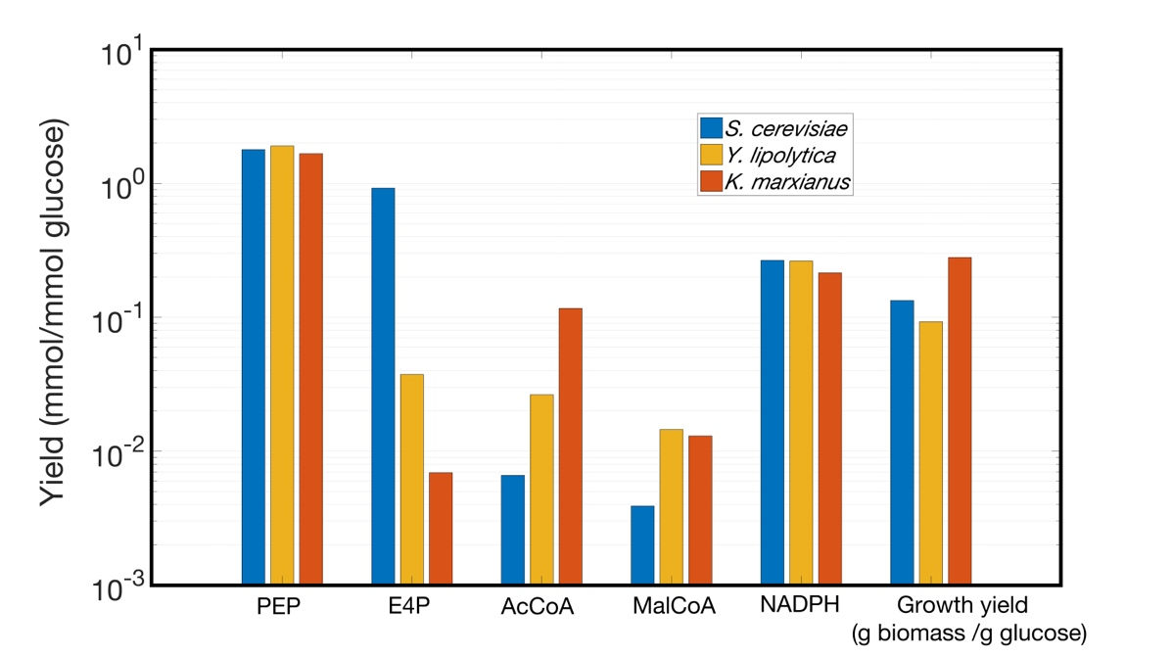

***Figure 4:*** *Prediction of precursors and growth rate yield in batch growth conditions.*

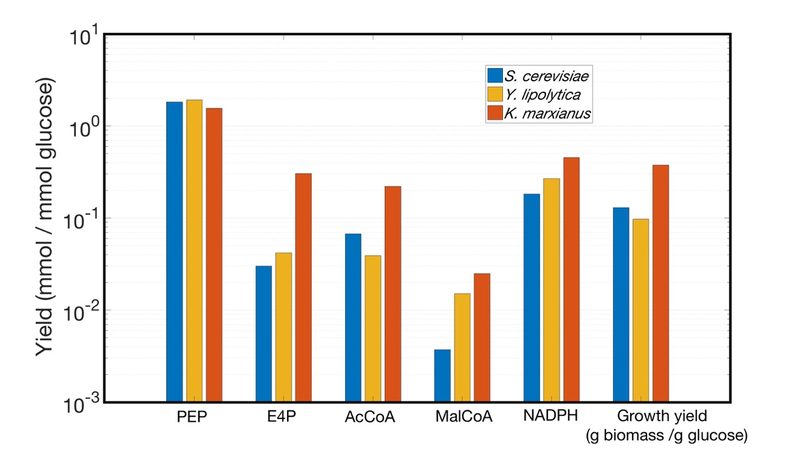

***Figure 5:*** *Prediction of precursors and growth rate yield under chemostat conditions.*

The production capabilities of the in-silico mutant strains, described in section 1 were also explored with simulations. ***Figures 6-7*** show a comparison of the production capabilities between wild-type models and the aromatic amino acids production strains and the fatty acid ones, respectively.

Simulations were performed just on batch models with the total protein content constraint and not for chemostat conditions, doing that would have implied the assumption that proteome allocation is the same one for the wild-type as for the mutant strains, which is a hard assumption when referring to individual enzyme levels.

It should be remarked that almost no significant improvement was found for any of the proposed mutants when compared to their correspondent wild-type strains. The only exception being an approximately two-fold increase in the acetyl-CoA production for the Sce-FAA strain.

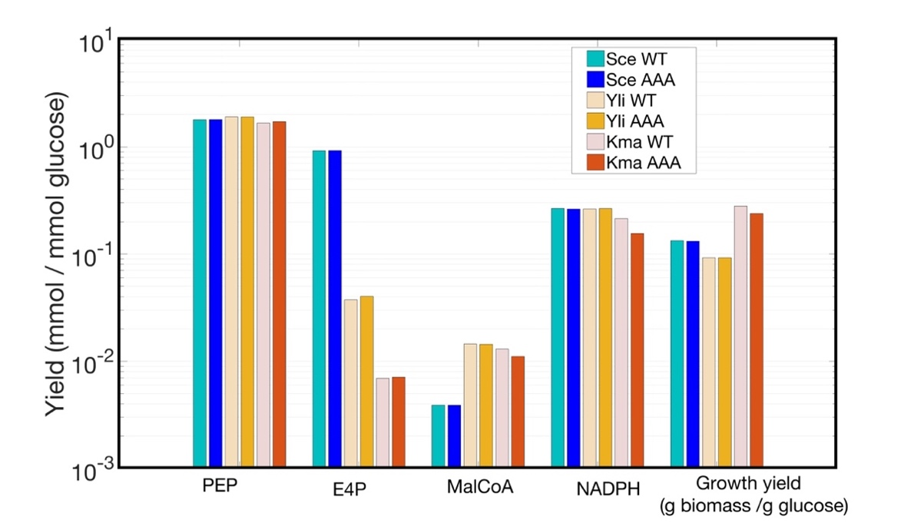

***Figure 6:*** *Prediction of precursors and growth rate yield under batch conditions for WT and proposed mutant strains for aromatic amino acids production.*

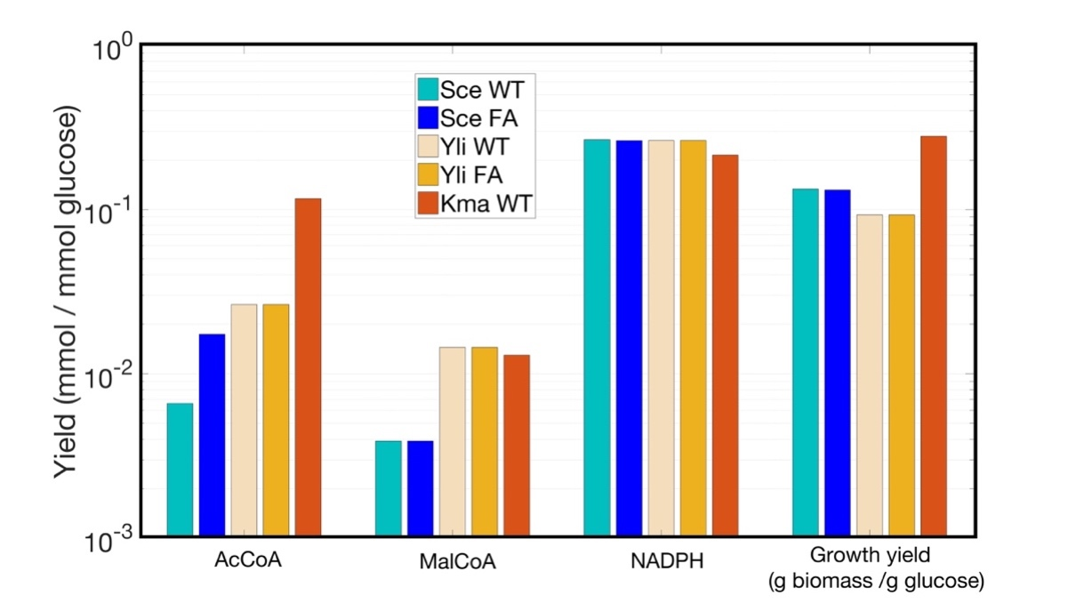

***Figure 7:*** *Prediction of precursors and growth rate yield under batch conditions for WT and proposed mutant strains for Acetyl-CoA production.*

However, this should not be necessarily taken as an unexpected or bad result, as all of the suggested genetic modifications sets included several overexpression of gene products. The correct representation of these modifications within the flux balance analysis framework is still a pending task, different approximations exist but GECKO is the only constraint-based modelling tool available for directly connect expression levels of proteins to metabolic reactions, nevertheless this can be done just for individually measured proteins and therefore, it cannot be applied for cases in which the total protein content is the only global constraint.

It should be suggested that these sets of modifications should not be discarded because no precursor formation yield was decreased for any of the mutants and just slight increases were observed on the yield values. However further experimental and *in-silico* exploration needs to be done on this regard.

# Systematic search of metabolic engineering targets

One of the most important advantages provided by genome-scale metabolic models is that they allow hypothesis testing and unbiased explorations of metabolism in a wide scale in relatively short times6. The typical FBA simulation for microbial models takes no more than one second to be completed by a personal computer due to the linear topology of GEMs7.

In order to address if the proposed mutant strains can be further improved single gene deletions were performed for every gene in the models and the fold changes in every of the precursors production yields was calculated on batch growth conditions. In this way, gene deletions that cause the most significant impact on the production targets, compared to wild-type solutions, can be considered for experimental testing or searched in literature for being included as part of metabolic engineering strategies for the chassis strains.

For obtaining interesting overexpression targets a different approach was used instead, Flux Scanning based on Enforced Objective Flux (FSEOF)8. This approach avoids the need of FBA-based simulations for an arbitrary overexpression factor for all genes, which directly assumes a linear impact of reaction rates.

FSEOF algorithm looks for all the genes connected to reactions that consistently increase their flux when the model is pushed to an optimized production for a product of interest. As an overexpression factor is not proposed, the only outcome is a score that ranks the impact of each overexpression, ranging from 0 to 100, and it is proportional to the fold changes of the precursors production between the optimal solution that maximizes precursors production over a base solution, maximizing for biomass production. A brief mathematical description and a review of the implicit assumptions of the methods used in this study is provided in ***Annex III***.

The most significant results of the genome-scale single gene deletions for the Sce_AAA strain can be visualized in ***figure 8***. Rows indicate the deleted gene; fold-changes for each precursor yield can be seen on columns; colours indicate the fold change, blue for increasing yields and red for decreasing ones. In this data visualization the existing trade-off between the production of aromatic amino acids precursors PEP and E4P and the cofactor NADPH is clearly shown.

Gene deletions with the highest overall yield increase (sum of all fold-changes) are considered as candidates for designing further metabolic strategies, the results filtering criteria is explained in ***annex IV***. The actual values of yield fold-change for the top interesting targets for deletions on Sce_AAA strain are shown in ***table 2*.** The top candidates for overexpression on the Sce_AAA strain are listed in ***table 3***, these are all the candidates for overexpressions that resulted to enhance the flux towards all the aromatic amino acids precursors simultaneously with the highest scores (100).

As it can be seen in the tables above, several genes are proposed either for deletions or overexpression for enhancing aromatic amino acids production. However, if these suggestions are going to be implemented in the laboratory, further analysis needs to be done for determining the relevance of the suggested genes and discarding redundant modifications, for instance, deletions of contiguous or close genes in a linear pathway.

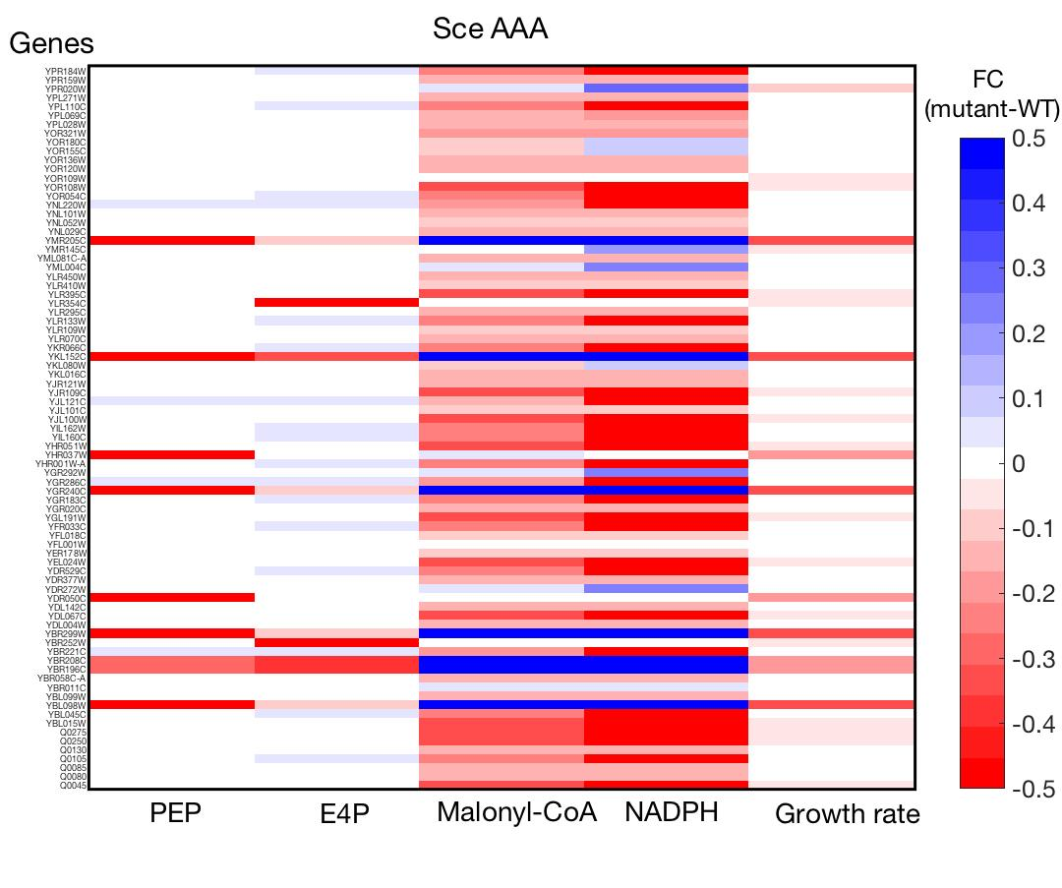

***Figure 8:*** *Precursors yield fold changes for single gene deletions on Sce_AAA strain.*

Table 2: Targets for gene deletions on mutant strain Sce_AAA

|  |  |  |  |  |  |  |
| --- | --- | --- | --- | --- | --- | --- |
| Gene ID | Protein ID | PEP | E4P | Malonyl-CoA | NADPH | Growth |
| YOR155C | Q99312 | 0.0160 | 0.0000 | -0.0861 | 0.0982 | -0.0120 |
| YOR180C | Q08558 | 0.0160 | 0.0000 | -0.0861 | 0.0982 | -0.0120 |
| YKL080W | P31412 | 0.0160 | 0.0000 | -0.0861 | 0.0982 | -0.0120 |
| YOR109W | Q12271 | 0.0000 | 0.0000 | 0.0232 | 0.0232 | -0.0422 |
| YER178W | P16387 | 0.0145 | 0.0162 | -0.0813 | -0.0813 | 0.0000 |
| YLR410W | Q06685 | 0.0145 | 0.0162 | -0.0813 | -0.0813 | 0.0000 |
| YNL052W | P00424 | 0.0145 | 0.0162 | -0.0813 | -0.0813 | 0.0000 |
| YLR109W | P38013 | 0.0145 | 0.0162 | -0.0813 | -0.0813 | 0.0000 |
| YJL101C | P32477 | 0.0145 | 0.0162 | -0.0813 | -0.0813 | 0.0000 |
| YFL018C | P09624 | 0.0145 | 0.0162 | -0.0813 | -0.0813 | 0.0000 |

Table 3: Targets for overexpression on mutant strain Sce_AAA

|  |  |  |
| --- | --- | --- |
| Gene ID | Protein ID | Enzyme name |
| YJR158W | P47185 | hexose transporter hxt16 |
| YLR109W | P38013 | peroxiredoxin type-2 (ec 1.11.1.15) |
| YOR120W | P14065 | glycerol 2-dehydrogenase (nadp(+)) (ec 1.1.1.156) |
| YJL052W | P00360 | glyceraldehyde-3-phosphate dehydrogenase 1 (ec 1.2.1.12) |
| YLR027C | P23542 | aspartate aminotransferase, cytoplasmic (ec 2.6.1.1) |
| YLR180W | P10659 | s-adenosylmethionine synthase 1 (adomet synthase 1) (ec 2.5.1.6 |

The same methods were applied to every proposed strain in section 1. ***Figure 9*** shows the results of systematic gene deletions on Sce_FAA strain for enhancing the production of fatty acids and fatty alcohols precursors. In this case, clearer strategies can be proposed, as there are seven gene deletions that were found to cause a high increase in the yield for the three precursors of interest.

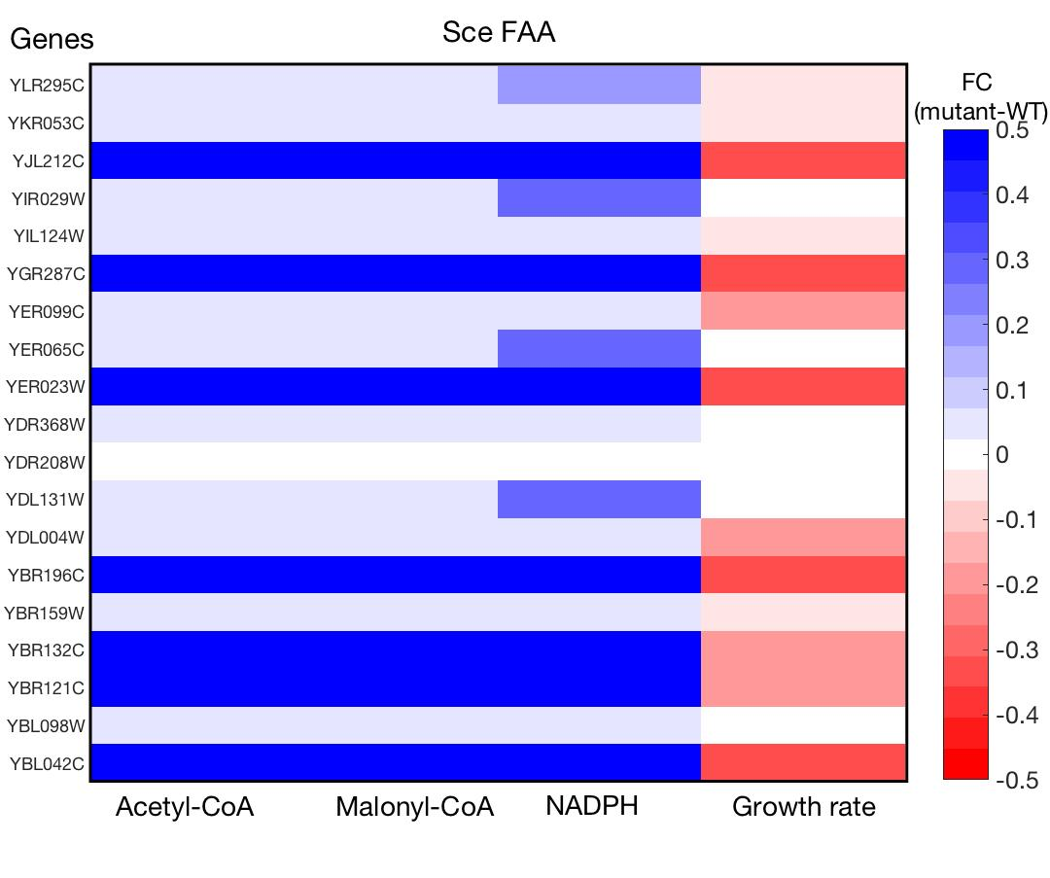

***Figure 9:*** *Precursors yield fold changes for single gene deletions on Sce_FAA strain.*

The gene deletions study on Yli_AAA strain revealed the same trend as in Sce_AAA, there are no deletions able to enhance PEP yield significantly without drastic decreases in the batch growth rate. For Yli_AAA several targets for deletions that enhance E4P and NADPH yields simultaneously, were found and can be seen on **figure 10**, the top results are listed in **table 6**. Top Candidate genes for overexpression are listed in **table 7**, the entries with empty name field were found in Uniprot with no associated functional name.

Table 4: Targets for gene deletions on mutant strain Sce_FAA

|  |  |  |  |  |  |
| --- | --- | --- | --- | --- | --- |
| Gene ID | Protein ID | Acetyl-CoA | Malonyl-CoA | NADPH | Growth |
| YBL042C | P38196 | 7.2759 | 2.4557 | 18.2093 | -0.3102 |
| YBR196C | P12709 | 7.2759 | 2.4557 | 18.2093 | -0.3102 |
| YJL212C | P40897 | 7.2759 | 2.4557 | 18.2093 | -0.3102 |
| YER023W | P32263 | 7.2759 | 2.4557 | 18.2093 | -0.3102 |
| YGR287C | P53051 | 2.0357 | 2.0357 | 8.6699 | -0.3275 |
| YBR132C | P38090 | 1.5822 | 1.5822 | 6.1003 | -0.1841 |
| YBR121C | P38088 | 1.5822 | 1.5822 | 6.1003 | -0.1841 |

Table 5: Targets for overexpression on mutant strain Sce_FAA

|  |  |  |
| --- | --- | --- |
| Gene ID | Protein ID | Enzyme name |
| YMR011W | P23585 | high-affinity glucose transporter hxt2 |
| YFL053W | P43550 | dihydroxyacetone kinase 2 (dha kinase 2) (ec 2.7.1.28) ´ |
| Q0250 | P00410 | cytochrome c oxidase subunit 2 (ec 1.9.3.1) |
| YCR012W | P00560 | phosphoglycerate kinase (ec 2.7.2.3) |
| YDL238C | Q07729 | probable guanine deaminase (guanase) (guanine aminase) (ec 3.5.4.3) |
| YEL024W | P08067 | cytochrome b-c1 complex subunit rieske, mitochondrial (ec 1.10.2.2) |
| YGR194C | P42826 | xylulose kinase (xylulokinase) (ec 2.7.1.17) |
| YGR254W | P00924 | enolase 1 (ec 4.2.1.11) (2-phospho-d-glycerate hydro-lyase 1) |
| YJR139C | P31116 | homoserine dehydrogenase (hdh) (ec 1.1.1.3) |
| YLR027C | P23542 | aspartate aminotransferase, cytoplasmic (ec 2.6.1.1) |
| YLR382C | P11325 | leucine--trna ligase, mitochondrial (ec 6.1.1.4) (leucyl-trna synthetase) |
| YLR447C | P32366 | v-type proton atpase subunit d (v-atpase subunit d) |
| YMR170C | P47771 | aldehyde dehydrogenase [nad(p)+] (ec 1.2.1.3) |
| YNL037C | P28834 | isocitrate dehydrogenase [nad] subunit 1, mitochondrial (ec 1.1.1.41) |
| YOR040W | Q12320 | hydroxyacylglutathione hydrolase, mitochondrial (ec 3.1.2.6) |
| YAL038W | P00549 | pyruvate kinase 1 (pk 1) (ec 2.7.1.40) |
| YDR322C-A | P81449 | atp synthase subunit e, mitochondrial (atpase subunit e) |
| YLR410W | Q06685 | inositol hexakisphosphate and diphosphoinositol-pentakisphosphate kinase (ec 2.7.4.21) (ec 2.7.4.24) |
| YNL071W | P12695 | dihydrolipoyllysine-residue acetyltransferase component of pyruvate dehydrogenase complex, mitochondrial (ec 2.3.1.12) |

The most significant gene deletions for fatty acids and alcohols production on Yli_FAA strain are shown in ***figure 11***, for most cases a tradeoff between acetyl-CoA and NADPH production can be noticed. Actually, it was found that just one gene deletion, out of 847 genes in the model, is able to cause a significant increase in acetyl-CoA without a drastic effect on NAPDH and biomass yields, which turned to be gene YALI0E14443g - **Phosphatidate cytidylyltransferase.**

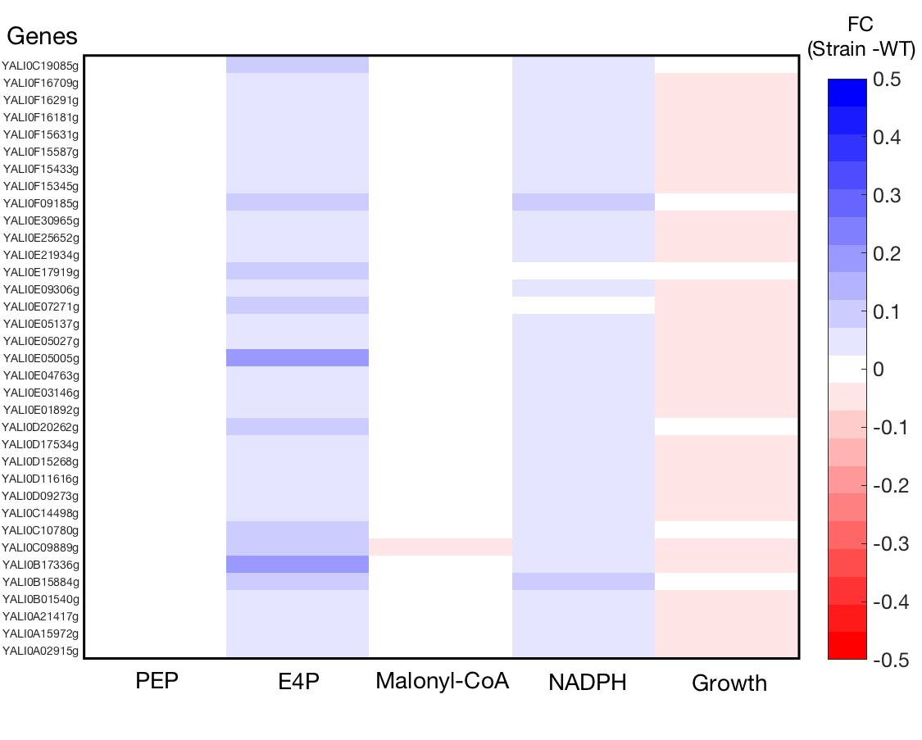

***Figure 10:*** *Precursors yield fold changes for single gene deletions on Yli_AAA strain.*

Table 6: Targets for deletion on mutant strain Yli_AAA

|  |  |  |  |  |  |  |
| --- | --- | --- | --- | --- | --- | --- |
| Gene ID | Protein ID | PEP | E4P | Malonyl-CoA | NADPH | Growth |
| YALI0B17336g | Q6CEA0 | 0.0000 | 0.1770 | 0.0000 | 0.0634 | -0.0322 |
| YALI0E05005g | Q6C6Z7 | 0.0000 | 0.1770 | 0.0000 | 0.0634 | -0.0322 |
| YALI0C19085g | Q6CBG4 | 0.0000 | 0.1096 | 0.0000 | 0.0705 | 0.0000 |
| YALI0C10780g | Q6CCB9 | 0.0000 | 0.1096 | 0.0000 | 0.0705 | 0.0000 |
| YALI0D20262g | Q6C8E6 | 0.0000 | 0.1096 | 0.0000 | 0.0705 | 0.0000 |
| YALI0B15884g | Q6CEG2 | 0.0000 | 0.1114 | 0.0000 | 0.0722 | -0.0202 |
| YALI0F09185g | P30614 | 0.0000 | 0.1114 | 0.0000 | 0.0722 | -0.0202 |
| YALI0E17919g | Q6C5H9 | 0.0000 | 0.0902 | 0.0000 | 0.0210 | 0.0000 |
| YALI0E07271g | Q6C6Q4 | 0.0000 | 0.0935 | 0.0000 | 0.0231 | -0.0258 |

Table 7: Targets for overexpression on mutant strain Yli_AAA

|  |  |  |
| --- | --- | --- |
| Gene ID | Protein ID | Enzyme name |
| YALI0A01133g | Q6CI67 |  |
| YALI0B03630g | Q6CFU6 |  |
| YALI0B07227g | Q6CFG4 |  |
| YALI0B22902g | Q6CDM0 | kynureninase (ec 3.7.1.3) |
| YALI0B23188g | Q6CDK7 |  |
| YALI0D01089g | Q6CAP2 |  |
| YALI0D04246g | Q6CAB6 |  |
| YALI0D11814g | Q6C9E6 |  |
| YALI0D16379g | Q6C8W4 | patatin-like phospholipase domain-containing protein yali0d16379g (ec 3.1.1.-) |
| YALI0D18568g | Q6C8M0 |  |
| YALI0D21604g | Q6C893 |  |
| YALI0E11671g | Q6C682 |  |
| YALI0E16709g | Q6C5M8 |  |
| YALI0E16753g | Q6C5M6 |  |
| YALI0E19723g | Q6C5A3 |  |
| YALI0E28963g | Q6C482 | adenylosuccinate synthetase (ampsase) (adss) (ec 6.3.4.4) |
| YALI0E34749g | Q6C3H7 |  |
| YALI0F04103g | Q6C2Y3 |  |
| YALI0F09185g | P30614 | pyruvate kinase (pk) (ec 2.7.1.40) |
| YALI0F16819g | Q6C1F3 | enolase (ec 4.2.1.11) (2-phospho-d-glycerate hydro-lyase) |
| YALI0F20306g | Q6C105 |  |

*In-silico* gene deletions on strain Kma_AAA revealed that there is only one gene that, when deleted, the yield of PEP, E4P and NAPH is simultaneously enhanced (***figure 12*** and ***table 10***). The candidate genes for overexpression included in ***table 11*** are the ones that increase the flux towards E4P and PEP without a decrease in the flux levels towards malonyl-CoA and NADPH (K-scores>1).

As there was no suggested strain for fatty acids and alcohols production on *K. marxianus*, genome-scale single gene knockouts and the FSEOF algorithm were applied to the wild-type model. ***Figure 13*** and ***table 12*** show evident targets that enhance the yield for all precursors with almost no impact in the batch growth rate. As with the other organisms, it can be seen how for several genes the precursors yield fold changes are exactly the same, it might be the case that these cases are either genes located in linear pathways or genes with closely related functions, this needs to be analyzed for all the results suggested by simulations and, in that way, reduce the set of modifications to test experimentally.

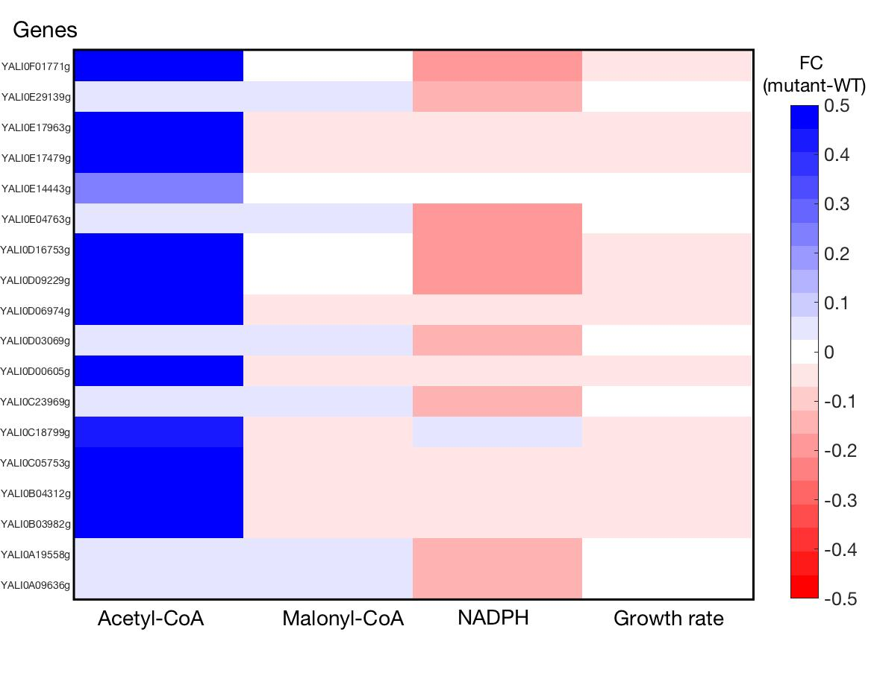

***Figure 11:*** *Precursors yield fold changes for single gene deletions on Yli_FAA strain.*

Table 8: Targets for deletion on mutant strain Yli_FAA

|  |  |  |  |  |
| --- | --- | --- | --- | --- |
| Gene ID | Protein ID | Acetyl-CoA | Malonyl-CoA | NADPH |
| YALI0A09636g | Q6CHE9 | 0.0507 | 0.0507 | -0.1556 |
| YALI0A19558g | Q6CGG5 | 0.0525 | 0.0525 | -0.1654 |
| YALI0C23969g | Q6CAV8 | 0.0539 | 0.0539 | -0.1644 |
| YALI0D03069g | Q6CAG1 | 0.0507 | 0.0507 | -0.1556 |
| YALI0E04763g | Q6C706 | 0.0331 | 0.0331 | -0.1697 |
| YALI0E14443g | Q6C5X0 | 0.2420 | 0.0000 | 0.0000 |
| YALI0E29139g | Q6C474 | 0.0507 | 0.0507 | -0.1556 |

Table 9: Targets for overexpression mutant strain Yli_FAA

|  |  |  |
| --- | --- | --- |
| Gene ID | Protein ID | Enzyme name |
| YALI0A01133g | Q6CI67 |  |
| YALI0B00396g | Q6CG69 |  |
| YALI0B06831g | Q6CFH9 |  |
| YALI0B06941g | Q6CFH4 | ribose-5-phosphate isomerase (ec 5.3.1.6) |
| YALI0B16522g | Q6CED5 |  |
| YALI0B20196g | Q6CDY7 |  |
| YALI0C05258g | Q6CCZ6 |  |
| YALI0C06446g | Q6CCU5 |  |
| YALI0D02629g | Q6CAH9 |  |
| YALI0D04741g | Q6CA97 |  |
| YALI0D12584g | Q6C9B1 |  |
| YALI0D16797g | Q6C8V1 | enolase-phosphatase e1 (ec 3.1.3.77 |
| YALI0D17842g | Q6C8Q4 |  |
| YALI0D22484g | Q6C859 |  |
| YALI0E12628g | B5FVH7 |  |
| YALI0E14102g | Q6C5Y3 |  |
| YALI0E17479g | Q6C5J7 |  |
| YALI0E18029g | Q6C5H4 | glutathione reductase (gr) (grase) (ec 1.8.1.7) |
| YALI0E32164g | B5FVG3 |  |
| YALI0E34265g | Q6C3J7 |  |
| YALI0F05500g | Q6C2S7 |  |
| YALI0F11759g | Q6C211 |  |
| YALI0F13453g | Q6C1T8 |  |
| YALI0F16819g | Q6C1F3 | enolase (ec 4.2.1.11) (2-phospho-d-glycerate hydro-lyase) |

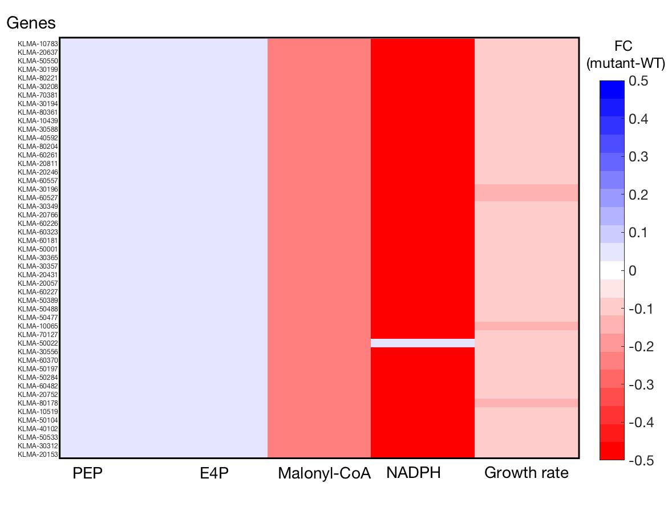

***Figure 12:*** *Precursors yield fold changes for single gene deletions on Kma_AAA strain.*

Table 10: Targets for deletion on mutant strain Kma_AAA

|  |  |  |  |  |  |  |  |
| --- | --- | --- | --- | --- | --- | --- | --- |
| Gene Ids | Protein Ids | Enzyme names | PEP | E4P | Malonyl-CoA | NADPH | Growth |
| KLMA_50022 | W0TCY9 | Glycerophosphodiester phosphodiesterase gde1 | 0.0303 | 0.0262 | -0.1466 | 0.0235 | -0.0535 |

Table 11: Targets for overexpression on mutant strain Kma_AAA

|  |  |  |
| --- | --- | --- |
| Gene Ids | Protein Ids | Enzyme names |
| KLMA_10294 | W0T541 | hypoxanthine-guanine phosphoribosyltransferase |
| KLMA_40502 | W0TCJ1 | xanthine phosphoribosyltransferase 1 |
| KLMA_40587 | W0TCS1 | adenine phosphoribosyltransferase |

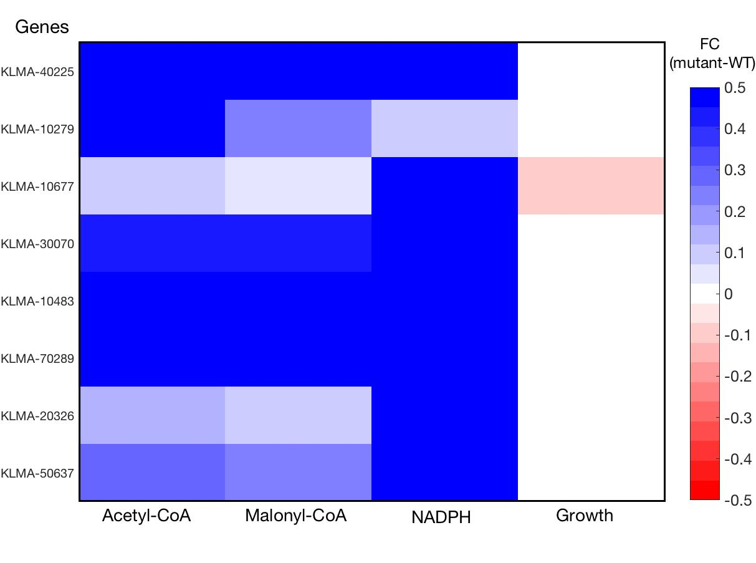

***Figure 13:*** *Precursors yield fold changes for single gene deletions on Kma_WT strain.*

Table 12: Targets for deletion on mutant strain Kma_WT

|  |  |  |  |  |  |
| --- | --- | --- | --- | --- | --- |
| Gene Ids | Protein Ids | Acetyl-CoA | Malonyl-CoA | NADPH | Growth |
| KLMA_70289 | W0TER2 | 0.76207107 | 0.69350394 | 19.3481208 | 0 |
| KLMA_10483 | W0T3X2 | 0.76207107 | 0.69350394 | 19.3481208 | 0 |
| KLMA_40225 | W0TDQ2 | 0.76033933 | 0.69269065 | 19.3121637 | 0 |
| KLMA_50637 | W0TES8 | 0.27820333 | 0.21915296 | 8.89678159 | 0 |
| KLMA_30070 | W0T7J3 | 0.40528153 | 0.40528153 | 6.96407293 | 0 |
| KLMA_20326 | W0T9L2 | 0.12947094 | 0.0772917 | 5.64186234 | 0 |
| KLMA_10677 | W0T8A1 | 0.07883649 | 0.02899646 | 5.24106157 | -0.0805876 |
| KLMA_10279 | W0T527 | 0.70667822 | 0.24914655 | 0.1119464 | 0 |

Table 13: Targets for overexpression on mutant strain Kma_WT

|  |  |  |
| --- | --- | --- |
| Gene Ids | Protein Ids | Enzyme names |
| KLMA_20798 | W0T8W6 | ctag_cox11 super family |
| KLMA_60075 | W0TEZ4 | pyruvate decarboxylase |

# 

# References

1. Sánchez, B. J. *et al.* Improving the phenotype predictions of a yeast genome‐scale metabolic model by incorporating enzymatic constraints. *Mol. Syst. Biol.* **13,** 935 (2017).

2. Lewis, N. E. *et al.* Omic data from evolved E. coli are consistent with computed optimal growth from genome-scale models. *Mol. Syst. Biol.* **6,** (2010).

3. Van Dijken, J. P. *et al.* An interlaboratory comparison of physiological and genetic properties of four Saccharomyces cerevisiae strains. *Enzyme Microb. Technol.* **26,** 706–714 (2000).

4. Fontanille, P., Kumar, V., Christophe, G., Nouaille, R. & Larroche, C. Bioconversion of volatile fatty acids into lipids by the oleaginous yeast Yarrowia lipolytica. *Bioresour. Technol.* **114,** 443–449 (2012).

5. Bellaver, L. H., Barbosa De Carvalho, N. M., Abrahão-Neto, J. & Gombert, A. K. Ethanol formation and enzyme activities around glucose-6-phosphate in Kluyveromyces marxianus CBS 6556 exposed to glucose or lactose excess. *FEMS Yeast Res.* **4,** 691–698 (2004).

6. O’Brien, E. J., Monk, J. M. & Palsson, B. O. Using genome-scale models to predict biological capabilities. *Cell* **161,** 971–987 (2015).

7. Orth, J. D., Thiele, I. & Palsson, B. Ø. What is flux balance analysis? *Nat. Biotechnol.* **28,** 245–248 (2010).

8. Choi, H. S., Lee, S. Y., Kim, T. Y. & Woo, H. M. In silico identification of gene amplification targets for improvement of lycopene production. *Appl. Environ. Microbiol.* **76,** 3097–3105 (2010).

# Annex I: *In-Silico* strains modifications

The CHASSY project consortium was consulted for gathering suggestions on sets of genetic modifications for the enhancing the production of the precursor and cofactor molecules of interest (PEP, E4P, Malonyl-CoA and NADPH for amorfrutin-1 production; Acetyl-CoA, Malonyl-CoA and NADPH for octanoic acid and docosanol production) in the three yeast especies. The proposals are summarized in tables AI.1-5.

For each mutant strain a specific EC-GEM was generated, using the base EC-Model for the three organisms as a basis. GEMs represent the metabolic network of an organism based on gene(s)-reaction(s) associations. An interesting feature of enzyme-constrained models is that complex relationships such as isoenzymes, promiscuous enzymes or enzyme complexes are taken into account for the imposition of constraints, in contrast to classic stoichiometric models. However, protein synthesis and enzyme regulation processes are still not represented in this modelling framework.

The adaptation of a GEM to a strain specific model can be done via the next three modifications:

1. Gene deletions: The gene is deleted from the model. Reactions catalysed by a single enzyme or enzyme complex encoded by the gene are blocked (lower and upper bounds for the correspondent flux are set to zero). For the cases in which the gene is not related to all of the isoenzymes catalysing a specific reaction, this is kept without modifications.
2. Overexpression: For the cases in which the gene to overexpress encodes an enzyme that is included in the model, the correspondent enzyme usage reaction upper bound (equal to the measured abundance) is multiplied by a given OE factor. For genes that are not connected to any enzyme incorporated in the model, the stoichiometric coefficients of all its related reactions are multiplied by the specified OE factor.
3. Expression of heterologous gene products: For this modification there might be two different cases; If the introduced gene encodes for a reaction that is not part of the model, this is going to be incorporated, with all its necessary elements if data is available (enzyme uniport codes, Kcat values, reported constraints); if the reaction was already in the model, all the related elements and parameters of the reaction are modified accordingly with the new gene information, for this, further parameters and data collection needs to be done.

*Table AI.1.-* Mutant *S. cerevisiae* strain for enhanced production of aromatic amino acids

|  |  |  |  |  |
| --- | --- | --- | --- | --- |
| Gene names | IDs | Uniprot ID | Enzyme name | Modification |
| ARO3 | YDR035W | P14843 | DAHP synthase | deletion |
| PDC5* | YLR134W | P16467 | pyruvate decarboxylase | deletion |
| PDC6 | YGR087C | P26263 | pyruvate decarboxylase | deletion |
| ARO10 | YDR380W | Q06408 | phenylpyruvate decarboxylase | deletion |
| ARO8* | YGL202W | P53090 | aromatic aminotransferase I | deletion |
| ARO4 | YBR249C | P32449 | DAHP synthase | overexpression |
| ARO7 | YPR060C | P32178 | chorismate mutase | overexpression |
| ARO1 | YDR127W | P08566 | multifunctional enzyme | overexpression |
| PHA2 | YNL316C | P32452 | prephenate dehydratase | overexpression |
| TYR1 | YBR166C | P20049 | prephenate dehydrogenase | overexpression |
| ARO9 | YHR137W | P38840 | aromatic aminotransferase II | overexpression |
| ARO2 | YGL148W | P28777 | bifunctional chorismate synthase, flavin reductase | overexpression |
| RPE1 | YJL121C | P46969 | D-ribulose-5-phosphate 3-epimerase | overexpression |
| RKI1 | YOR095C | Q12189 | ribose-5-phosphate ketol-isomerase | overexpression |
| TAL1 | YLR354C | P15019 | transaldolase | overexpression |
| TKL1 | YPR074C | P23254 | transketolase | overexpression |

*Modifications not included in the *in-Silico* mutant because they resulted to be essential genes for the model to yield feasible solutions.

*Table AI.2.-* Mutant *S. cerevisiae* strain for enhanced production of Acetyl-CoA

|  |  |  |  |  |
| --- | --- | --- | --- | --- |
| Gene names | IDs | Uniprot ID | Enzyme name | Modification |
| *ADH1\** | YOL086C | P00330 | alcohol dehydrogenase 1 | deletion |
| *ADH2* | YMR303C | P00331 | alcohol dehydrogenase 2 | deletion |
| *ADH3* | YMR083W | P07246 | alcohol dehydrogenase 3 | deletion |
| *ADH4* | YGL256W | P10127 | alcohol dehydrogenase 4 | deletion |
| *ADH5* | YBR145W | P38113 | alcohol dehydrogenase 5 | deletion |
| *ADH6* | YMR318C | Q04894 | alcohol dehydrogenase 6 | deletion, replaced by pantothenate kinase coaA from E. coli under PMA1 promoter |
| *SFA1* | YDL168W | P32771 | bifunctional ADH and formaldehyde DH | deletion, replaced by acetylating aldehyde dehydrogenase adhE A267T/E568K/R577S from E. coli under PFK1 promoter |
| *FMS1* | YMR020W | P50264 | Polyamine oxidase | overexpression, PADH1-FMS1 |

*When all ADH isoforms are deleted from the mutant model it is not able to grow. ADH1 was kept for being the lightest (in terms of mass) of these proteins, so it will contribute in a lower extent to the total protein burden of the model.

*Table AI.3.-* Mutant *Y. lipolytica* strain for enhanced production of aromatic amino acids

|  |  |  |  |  |
| --- | --- | --- | --- | --- |
| Gene names | IDs | Uniprot ID | Enzyme name | Modification |
| *ARO4* | YALI0C06952g | Q6CCS4 | DAHP synthase | deletion of WT copy, overexpression of feedback insensitive version (P*TEF*-*ARO4K221L*) |
| *ARO7* | YALI0E17479g | Q6C5J7 | chorismate mutase | deletion of WT copy, overexpression of feedback insensitive version (P*TEF*-*ARO7G139S*) |
| *ARO1* | YALI0F12639g | Q6C1X5 | multifunctional enzyme | Overexpression (P*TEF*-*ARO1*) |
| *ARO2* | YALI0D17930g | Q6C8Q1 | bifunctional chorismate synthase, flavin reductase | Overexpression (P*TEF*-*ARO2*) |
| *ARO3* | YALI0B20020g | Q6CDZ3 | DAHP synthase | Deletion of WT copy |
| *ARO10* | YALI0D06930g | Q6CA04 | phenylpyruvate decarboxylase | Deletion |
| *TKL1* | YALI0E06479g | Q6C6T4 | transketolase | overexpression, P*TEF*-*TKL1* |
| *GUT1* | YALI0F00484g | Q6C3E1 | Glycerol kinase | overexpression, P*TEF*-*GUT1* |
| *EYK1\** |  |  | Erythrulose kinase | Deletion |

*No gene and protein IDs were found for this gene in the Uniprot database for *Y. lipolytica.*

*Table AI.4.-* Mutant *Y. lipolytica* strain for enhanced production of acetyl-CoA

|  |  |  |  |  |
| --- | --- | --- | --- | --- |
| Gene names | IDs | Uniprot ID | Enzyme name | Modification |
| *ACC1* | YALI0C11407g | Q6CC91 | Acetyl-coA carboxylase | Deregulation P*TEF*-*ACC1* |
| *ACS2po* |  | Q6C2Q5 | Acetyl-coA synthetase | Overexpression. P*TEF*-*ACS-peroxysome* |
| *ACS2cyt\** |  |  | Acetyl-coA synthetase | Overexpression. P*TEF*-*ACS-cytosolic* |

*Both genes were not found in Uniprot for *Y. lipolytica* and, hence, neither in the model however ACS is part of the model (gene:YALI0F05962g, protein:Q6C2Q5) and was overexpressed in the mutant model.

*Table AI.5.-* Mutant *K. marxianus* strain for enhanced production of aromatic amino acids.

|  |  |  |  |  |
| --- | --- | --- | --- | --- |
| Gene names | IDs | Uniprot ID | Enzyme name | Modification |
| *ARO3* | KLMA_40107 | W0TBD2 | DAHP synthase | deletion |
| *ARO4* | KLMA_20414 | W0T5I6 | DAHP synthase | deletion of WT copy, overexpression of feedback insensitive version (*PDC1pr*-*ARO4K221L*). |
| *ARO7* | KLMA_80332 | W0THU4 | chorismate mutase | deletion of WT copy, overexpression of feedback insensitive version (*TEF1pr*-*ARO7G141S*). |
| *ARO1* | KLMA_40161 |  | multifunctional enzyme | overexpression, *TSA1pr*-*ARO1* . |
| *PHA2* | *KLMA_70162* |  | prephenate dehydratase | overexpression, *ENO1pr*-*PHA2* |
| *ARO9* | *KLMA_60423* |  | aromatic aminotransferase II | overexpression, *HSP150pr*-*ARO9* (based on YFP reporter assays, about 15-fold stronger) |
| *ARO2* | KLMA_80099 | W0TGD1 | bifunctional chorismate synthase, flavin reductase | overexpression, *PGK1pr*-*ARO2* |
| *RPE1* | KLMA_60024 | W0TD99 | D-ribulose-5-phosphate 3-epimerase | overexpression, *TDH3pr*-*RPE1* |
| *RKI1* | KLMA_80221 |  | ribose-5-phosphate ketol-isomerase | overexpression, *TSA1pr*-*RKI1* |
| *TAL1* | KLMA_30634 | W0TCV6 | transaldolase | overexpression, *PGK1pr*-*TAL1* |
| *TKL1* | KLMA_80302 | W0THR5 | transketolase | overexpression, *TEF1pr* -*TKL1* |
| *ENO1* | *KLMA_10462* |  | Enolase (only one isoform in *K.marxianus*) | Overexpression, *PDC1pr*-*ENO1*  (based on YFP reporter assays, about 2.5-fold). |
| *PDC5* | KLMA_60075 | W0TEZ4 | pyruvate decarboxylase | Deletion |
| *ARO10* | *KLMA_20597* |  | phenylpyruvate decarboxylase | deletion |
| *ARO8* | KLMA_20259 | W0T517 | aromatic aminotransferase I | Deletion |
| *ARO8-2* | KLMA_50151 | W0TBP5 | aromatic aminotransferase I | Deletion |
| *ZWF1* | KLMA_50631 | W0TCY6 | Glucose-6-phosphate dehydrogenase | Deletion |

# Annex II: Simulation caveats

The following procedure was followed to simulate batch growth:

1. Remove constraints on the glucose uptake reactions [mmol/gDWh].
2. Change the media to minimal, this means that the upper bounds for uptake of amino acids and nucleotides (not present on the media) are set to zero.
3. Limit total enzyme mass by 0.435 g/gDW for *S. cerevisiae*, 0.467 for *Y. lipolytica* and 0.389 for *K. marxianus*. An average enzyme saturation factor of 0.5 was assumed in all cases.
4. Maximize growth.
5. Fix growth at optimal value, allowing a 0.1% flexibility to avoid numerical errors. Minimize total sum of fluxes for avoiding futile cycles.

For growth on chemostat conditions the next procedure was followed:

1. Fix the specific growth rate at the dilution rate value (0.1 h-1).
2. Remove constraints on glucose and oxygen uptake rates [mmol/gDwh].
3. Limit individual enzyme levels with concentration values [mmol/gDw] calculated by equation 1 from proteomic measurements.
4. Calculate f, the fraction of unmeasured proteins and constrain the protein pool with a value of f*Ptotal.
5. Minimize for glucose uptake rate.
6. Fix substrate uptake to optimal value, then minimize enzyme usage to obtain the most thermodynamically feasible solution.

# Annex III: Mathematical methods for models optimization and analysis

**AIII.1 Parsimonious FBA**

For performing growth simulations on the models pFBA has been applied to the models, as GECKO models have the structure of linear constraint-based models. In GEMs, metabolic reactions are represented as a stoichiometric matrix (***S***) of size equal to the number of metabolites (m) times the number of reactions (n). Every row in the matrix represents a unique metabolite and every row, a reaction. The numerical entries correspond to stoichiometric coefficients for every reaction. Assuming a metabolic steady-state, with shorter characteristic times in comparison to the fermenters, the mass balance for all the metabolites in the network can be expressed as:

$$S∙v=0 [A1]$$

In which $v$ represents the vector of reaction fluxes in mmol/gDwh. Every flux distribution that satisfies this equation is said to lay within the null-space of ***S***, sometimes called the solution space. In any genome-scale metabolic model, there are much more reactions than metabolites, due to the high connectivity and robustness of metabolism, therefore equation [*A1*] describes an underdetermined system with an infinite number of solutions.

Physiological and environmental constraints can be set as lower or upper bounds to individual reactions (free variables) and, if a linear combination of fluxes is set up as an objective function, usually for biomass production maximization, the problem can be solved and a numerical solution can be found. In summary a FBA problem can be set as7:

In parsimonious FBA simulations it is assumed that a cell operates looking for the most stoichiometrically efficient functional state2, hence, once biomass has been maximized, the optimal value is fixed and then a new objective function, the total sum of gene associated fluxes, is minimized.

The implementation of this method provides the advantage of getting rid of thermodynamically unfeasible futile cycles in the computed flux distributions.

**AIII.2 Flux scanning with enforced objective function**

Identification of gene targets for deletion in metabolic engineering might be a straightforward process, if a functional GEM is available. However, identifying gene targets for amplification is not as easy. FSEOF was developed for this purpose with the conceptual advantage of avoid the need of an arbitrary overexpression factor that affect reactions stoichiometries. This method takes into account the trade-off between biomass and products formation and it focuses on quantitative trends of fluxes when switching from growth to products maximization. Its mathematical definition can be summarized as follows:

1. Maximize for biomass production and get the value of the reaction(s) of interest from the solution (${v_{x}}^{min}$).
2. Maximize for the production reaction of interest and save the value as ${v_{x}}^{max}$.
3. Iterate maximizing for biomass while fixing $v_{x}$, spanning from ${v_{x}}^{min}$ to ${v_{x}}^{max}$ in regular intervals.
4. Select fluxes that satisfy $\left|{v_{j}}^{max}\right|>\left|{v_{j}}^{min}\right|$ and ${v_{j}}^{max}×{v_{j}}^{min}≥0$ (overall increase and directionality consistency) as candidate fluxes for amplification.

Typically, this method yields a high number of interesting candidates for overexpression, in this study a ratio $\frac{\left|{v_{j}}^{max}\right|}{\left|{v_{j}}^{min}\right|}$ is used as a ranking score for selecting the most interesting targets. Scores equal to zero represent fluxes that are turned off when the flux of interest is enforced; scores lower than one represent reaction fluxes that are decreased while enforcement; scores higher than one represent fluxes that increase their value with the enforced objective. Finally, scores higher than 100 were truncated to that value.

# Annex IV: Filtering out simulation results

As gene deletion and FSEOF studies were performed in a genome-scale for each modelled strain, the simulation results size is of the same order as the number of genes included in the models (~900). In order to get the most significant results in a systematic way, data filtering criteria are needed.

The main output from the gene deletions simulations is a matrix of size **m** x **n+1**, where **m** is the number of genes in a model and **n** the number of precursors, the extra column represents the biomass production. In every cell, production and biomass yields (over glucose consumption) fold changes are stored. The heatmaps on section 4 show the genes (rows) that meet the following conditions:

* Improved yield with respect to the wild-type solution for at least two of the columns (precursors and biomass).
* Improved yield with respect to the base solution of the suggested mutants for at least two rows (proposed mutants do not necessarily yield higher yields than the wild type models for all the studied precursors).
* The optimal biomass production must be, at least, 50% of the wild type maximal growth rate.
* The production yield for all the precursors must be higher than 50% of the wild type solution values.

For FSEOF results, just those gene targets which present a ranking score higher than one for all of the precursors are kept and shown on the tables 3, 5, 7, 9, 11 and 13 in section 4.

These filtering criteria tries to keep the most relevant results, focusing on targets able to enhance precursors production in an integral way without sacrificing the cells growth too much, rather than taking those that just increase a specific product, which in most cases may lead to growth deficient phenotypes in the laboratory.